

**Product Dissection for EcoConnect**

**Company Overview:**

EcoConnect is the UK’s green industry business network, connecting companies, communities and individuals working in the low carbon sector by providing essential links to investment, business support, industry expertise and thought leadership. As a non-profit, politically independent agency, EcoConnect’s business mission is to help accelerate the UK’s transition to a green economy.

### **Product Dissection and Real-World Problems Solved by EcoConnect:**

**The Problem**:

EcoConnect relies heavily on its events to engage its members and attract new ones. According to Chief Executive Robert Hokin, “Events are essential to EcoConnect. They are intimate experiences that demonstrate the value of our organization to members and prospective members.”

Prior to partnering with Cvent, EcoConnect was struggling to automate its event management administration. They were using a Cvent competitor at the time and wanted to hold more events, greatly expand its audience, and further engage its current membership base, but the organization’s events management provider didn’t have the depth or flexibility to help EcoConnect reach its ambitious goals.

“Our needs had simply outgrown our previous provider,” said Hokin. “It was time to make a change.”

**The Solution:**

Before coming on board with Cvent, EcoConnect didn’t have a very refined process for using its events to attract new members—even though it offered interesting and informative experiences. That all changed when EcoConnect began using Cvent’s event management platform technology in 2009.

From the onset EcoConnect took advantage of Cvent features that could help the organization increase its awareness among prospective members.

They started by using Cvent’s invitation forwarding option to enable invitees to forward their registration confirmation emails to other people potentially interested in attending. They also used the online event registration pages built with Cvent to capture more referrals. This gave members the option to register up to five non-member guests per event. Once new contacts were registered, they were automatically saved in Cvent’s database and cataloged in a prospective member contact group. That way the team at EcoConnect could follow up with them and continue to promote membership after the event ended.

In order to increase overall attendance at events, EcoConnect implemented Cvent’s dynamic delegate visibility list, so invitees could see who was already registered to attend. Since a big part of the appeal of EcoConnect’s events is the networking aspect, this sparked an immediate increase in attendance.

Another method for ramping up registrations came in the form of Cvent’s abandoned registration report. With this report, ecoConnect could see who may had started to register but not complete, and then send emails to remind invitees to finish their registrations.

Post-event, Ecoconnect keeps delegates even more engaged by sending them targeted thank you emails with links to the event website; where content resources, blogs and event wrap-ups are posted.

# 

# 

# **Case Study:- EcoConnect's Event Management Transformation with Cvent**

## **The Problem:**

* Inadequate System: EcoConnect's previous event management provider didn't have the depth or flexibility to support the organization's ambitious goals.
* Limited Growth: The organization wanted to hold more events, expand its audience, and further engage its current membership base, but its existing system was a bottleneck.

## 

## **The Solution:**

EcoConnect adopted Cvent's event management platform in 2009, bringing a transformation in its event management and member engagement strategies.

### **Leveraging Cvent Features:**

1. Invitation Forwarding: EcoConnect used Cvent’s invitation forwarding option, allowing invitees to share registration confirmation emails with others interested in attending. This facilitated organic growth through referrals.
2. Online Registration Pages: Utilizing Cvent's online event registration pages, EcoConnect captured more referrals by allowing members to register multiple non-member guests per event. New contacts were automatically cataloged for post-event follow-ups.
3. Dynamic Delegate Visibility List: Implemented Cvent’s dynamic delegate visibility list to show who was already registered for an event. This increased attendance, especially considering EcoConnect's emphasis on networking.
4. Abandoned Registration Report: EcoConnect used Cvent’s abandoned registration report to identify individuals who started the registration process but didn't complete it. This allowed them to send reminders and encourage completion.
5. Post-Event Engagement: After events, EcoConnect kept delegates engaged by sending targeted thank-you emails with links to event resources, blogs, and wrap-ups on the website.

## **The Results:**

The adoption of Cvent brought significant positive outcomes for EcoConnect:

* Event Expansion: The number of events produced increased from 12 per year to 30.
* Membership Growth: EcoConnect substantially expanded its membership since 2009.
* Database Expansion: The organization built a substantial database of contacts.
* Operational Efficiency: Managed all event processes with a single staff member.

## **Testimonial:**

“We’re a small outfit, and there is absolutely no way that we could have grown and managed our audience and all the events we produce without Cvent. For us, Cvent is an invaluable partner that helps us build and manage the events environment we need for our business to succeed and grow. They are indispensable.” - Robert Hokin, CEO, EcoConnect

## 

## **Conclusion:**

Cvent's event management platform empowered EcoConnect to not only streamline its event processes but also significantly enhance member engagement, achieve substantial growth, and efficiently manage a burgeoning database. The partnership with Cvent became instrumental in EcoConnect's mission to accelerate the UK’s transition to a green economy.

### **Schema Description:**

Each table encapsulates essential aspects of ECOCONNECT, managing user information, environmental challenges, eco-friendly products, sustainability scores, community projects, educational resources, eco-awareness challenges, corporate sustainability profiles, and carbon footprint tracking, while establishing relationships between different elements within the platform.

**User Entity:**

* **UserID (Primary Key):** A unique identifier for each user involved in ECOCONNECT.
* **Username:** The chosen username for the user's account.
* **Email:** The user's email address for project-related communication.
* **Full_Name:** The user's full name as registered in the project.
* **Bio:** A brief description that users can provide to express themselves.
* **Registration_Date:** The date when the user joined the ECOCONNECT project.

**EnvironmentalChallenge Entity:**

* **ChallengeID (Primary Key):** A unique identifier for each environmental challenge.
* **Title:** Title of the environmental challenge.
* **Description:** Detailed information about the challenge.
* **Category:** Category under which the challenge falls.
* **Start_Date:** The starting date of the challenge.
* **End_Date:** The end date of the challenge.

**GreenProduct Entity:**

* **ProductID (Primary Key):** A unique identifier for each green product.
* **Name:** Name or title of the green product.
* **Description:** Detailed information about the green product.
* **Price:** The cost or price of the product.
* **SustainabilityScore:** Rating indicating the product's environmental impact.
* **Category:** Category under which the product falls.

**SustainabilityScorecard Entity:**

* **ScorecardID (Primary Key):** A unique identifier for each sustainability scorecard.
* **OrganizationName:** Name of the organization being assessed for sustainability.
* **Description:** Detailed information about the organization's sustainability practices.
* **SustainabilityScore:** Rating indicating the organization's sustainability level.

**CommunityProject Entity:**

* **ProjectID (Primary Key):** A unique identifier for each community project.
* **Title:** Title of the community project.
* **Description:** Detailed information about the community project.
* **Location:** The place where the community project is being carried out.
* **Start_Date:** The starting date of the community project.
* **End_Date:** The end date of the community project.
* **ProgressStatus:** Indicates the current status of the project (e.g., planning, ongoing, completed).

**EducationalResource Entity:**

* **ResourceID (Primary Key):** A unique identifier for each educational resource.
* **Title:** Title or name of the educational resource.
* **Description:** Detailed information about the educational resource.
* **Type:** The type or format of the resource (e.g., article, video, course).
* **AuthorPublisher:** Name or entity responsible for creating/publishing the resource.
* **Content:** Actual content of the educational resource.
* **TagsKeywords:** Tags or keywords for easy search and categorization.

**MonthlyEcoChallenge Entity:**

* **ChallengeID (Primary Key):** A unique identifier for each monthly eco-awareness challenge.
* **Title:** Title of the monthly eco-awareness challenge.
* **Description:** Detailed information about the challenge.
* **Theme:** Theme or focus of the challenge.
* **Start_Date:** The starting date of the challenge.
* **End_Date:** The end date of the challenge.
* **RewardsForCompletion:** Indicates rewards for completing the challenge.

**CorporateSustainabilityProfile Entity:**

* **ProfileID (Primary Key):** A unique identifier for each corporate sustainability profile.
* **OrganizationName:** Name of the organization or company.
* **Description:** Detailed information about the organization's sustainability initiatives and practices.
* **SustainabilityInitiatives:** Specific initiatives taken by the organization.
* **SustainabilityScore:** Rating indicating the organization's sustainability level.

**CarbonFootprintTracker Entity:**

* **TrackerID (Primary Key):** A unique identifier for each carbon footprint tracker record.
* **UserID:** Identifier referencing the User Entity.
* **Date:** Date for which the carbon footprint data is recorded.
* **CarbonFootprintData:** Data related to the user's carbon footprint (e.g., transportation, energy consumption).

**ER Diagram:**

Let's construct an ER diagram that vividly portrays the relationships and attributes of the entities within the EcoConnect schema. This ER diagram will serve as a visual representation, shedding light on the pivotal components of EcoConnect's data model. By employing this diagram, you'll gain a clearer grasp of the intricate interactions and connections that define the platform's dynamics.

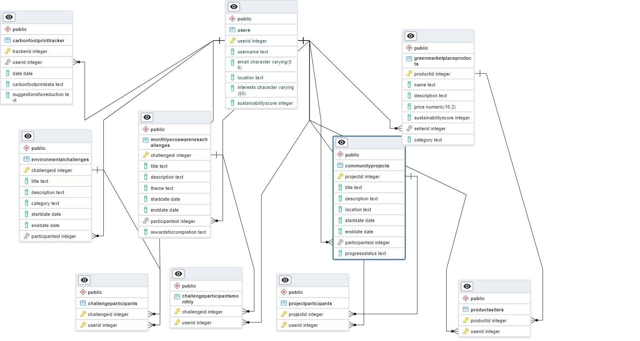

### **Conclusion:**

Overall, these interconnected tables provide a comprehensive infrastructure for managing and understanding sustainability-related data, fostering a robust platform for users to engage, learn, and contribute towards a more sustainable future.